

Course Name: Introduction to Software Engineering
Course Code: IS1103-1
Assignment Number: 1
Title: Study of Software Development Life Cycle Models with Reference to Savana
Student Name: Anika Sama
USN: NNM24IS026
Semester: IV
Section: A
Department: Information Science & Engineering
Institution Name: NMAM Institute of Technology
Academic Year: 2025-2026
Instructor Name: Dr Jason Elroy Martis
Date of Submission: 15-02-2026

ABSTRACT

This report walks through the full journey of building a product called Savana—a recommendation platform designed for girls. Savana advises on everything from fashion and beauty to lifestyle and school. The real challenge? Meeting a big mix of requirements. Some needs are about what Savana actually does; others are about how well it does it. And because users tastes and market trends keep shifting, the product has to keep up.

Since Savana relies on data to offer personal suggestions and has to be reliable, safe, and always available, picking the right way to build it is crucial. I’ll dive into three main approaches: Waterfall, incremental (bit by bit), and Spiral. I want to see which one handles changes best, keeps things secure, saves money, and moves quickly. It’s not just about checking boxes. It’s about making sure users’ needs come first, and that the AI behind recommendations stays smart.

We’ll get into the nitty-gritty too—things like signing up, making a profile, getting suggestions, searching for stuff, and more. And we’ll talk about what “working well” really means. Is it fast enough? Is it safe? Easy to use? These things matter, both now and down the line.
Checking if we actually solved users’ problems means more than just asking a few questions. We’ll show off what we’ve built, test for consistency, and see how well it matches up with what users want—especially with how fast fashion changes. That’s why I’m leaning toward incremental and Spiral approaches. They make it easier to adapt and stay secure, compared to the more rigid Waterfall method.

INTRODUCTION
This paper is about how we build Savana, an online recommendation system for girls. I’ll break down different ways to build software—Waterfall, Incremental, and Spiral—and how each one shapes the system and its features. We’ll look at what Savana needs, and how to check if everything’s working right. By comparing these methods, we can figure out the best way to build a system that needs constant updates, runs smoothly, and stays safe.

Savana uses smart data tools. Recommendation systems learn what users like, which helps them make better suggestions, show clearer results, and spot anything odd. By collecting lots of user data, Savana keeps users interested and makes the experience feel personal. This first section is about understanding user needs: building methods, checking those needs, defining what Savana should do, how well it should do it, and how to make sure we’ve got the needs right.

PROBLEM STATEMENT
I want to explore how Savana—a popular recommendation site for girls—can be built using different software development plans (the SDLC models). The goal is to see how Waterfall, Incremental, and Spiral models stack up for meeting what Savana needs. Since Savana has to keep up with changing tastes and trends, picking the right plan is a big deal.

I’ll lay out a basic list of needs: things like logging in, creating profiles, recommending products, searching, and paying. We also need to figure out how to check those needs and spot any issues. It’s not always easy to pin down what users want, especially with artificial intelligence in the mix, so we have to keep requirements clear and realistic.

The aim is to find which approach fits best for a fast-growing, ever-changing site like Savana. Since we don’t have insider details, we’ll stick to what usually works for recommendation sites and general rules for building software. Factors like time and simplicity will guide the features we choose.

SYSTEM DESCRIPTION
Savana’s a fast-growing recommendation site for girls. It’s a lively place to get ideas about fashion, beauty, lifestyle, and even school. Sellers can list products, and managers keep an eye on how the site’s running, what users are doing, and how secure everything is. Meanwhile, the system constantly tracks what’s trending and what users look at.

What makes Savana stand out is how quickly it changes. It never sits still for long. New AI features, sales, and user options pop up all the time. As users’ interests shift and new trends take off, Savana has to keep up. So, the platform is always evolving.

At the same time, Savana matters because it learns what users like and sometimes handles money too. The system needs to keep user data safe—no excuses. It also has to handle tons of people at once, especially when there’s a sale or it’s the holiday rush. Speed matters too. People expect quick searches, smooth navigation, and fast transactions. If it’s slow or doesn’t feel safe, folks just leave.

This site’s growing fast, runs on data, and puts users first. That makes it a pretty complex beast. Honestly, it’s a great case for looking at different ways to approach software development. It needs to adapt on the fly, stay ready for updates, and manage risks. That’s why it works well when you want to compare plans like Waterfall, Incremental, and Spiral.

TOOLS AND TECHNOLOGIES USED
• Documentation: Microsoft Word
• Diagram Design: Draw.io
• Version Control and Storage: GitHub

IMPLEMENTATION
We built the Savana recommendation platform with a clear plan, step by step, focusing on what we want the system to do and how we want it to do it. The main features? Sign-up, user profiles, search, suggestions, wish lists, and secure payments. Under the hood, we focused on safety, speed, scaling up, reliability, and making things easy for users.

We broke the system down into a few main pieces:
• User: Handles sign-ups, log-ins, and profiles.
• Suggestion Engine: Digs through the data and gives users recommendations.
• Product Place: Stores products, categories, and search functions.
• Cart and Order: Manages picking out products and placing orders.
• Payment: Takes care of secure payments.
• Admin and Analytics: Tracks what’s happening in the system and with users.

We didn’t build everything at once. Instead, we rolled it out piece by piece. First came sign-up and browsing. Then we added the suggestion box and wish lists. Later, we brought in upgrades and data tools.

Testing happens at every stage. We check each part by itself, then see how they play together, then test the whole system, and finally get real users involved.

After testing, we launch the app on the cloud so it can handle more people. We keep fixing bugs, checking data, and adding new features as we go.

1. Waterfall Model for Savana
The Waterfall model is all about following a strict order. You finish one stage, then move on to the next—no jumping ahead. Roger S. Pressman lays it out pretty clearly: you set your requirements at the start and stick with them.

So, if Savana goes with this model, everything—registration, suggestions, products, payment, security, the whole lot—needs to be mapped out and locked in before anyone writes a single line of code. The team can’t build or test anything until all decisions are made upfront. Once the project’s built, they test it top to bottom to catch mistakes and make sure it’s safe before launch.

But here’s the snag. Savana depends a lot on what users want, what’s trending, and fresh ideas. If something changes midway—say, a new feature or a shift in user behavior—fixing it is a pain. The Waterfall model doesn’t do “change on the fly.” If you want to rearrange anything, it’ll cost you time and money. Speeding through the steps sounds nice, but sticking to this plan makes it tough to adapt when you really need to.

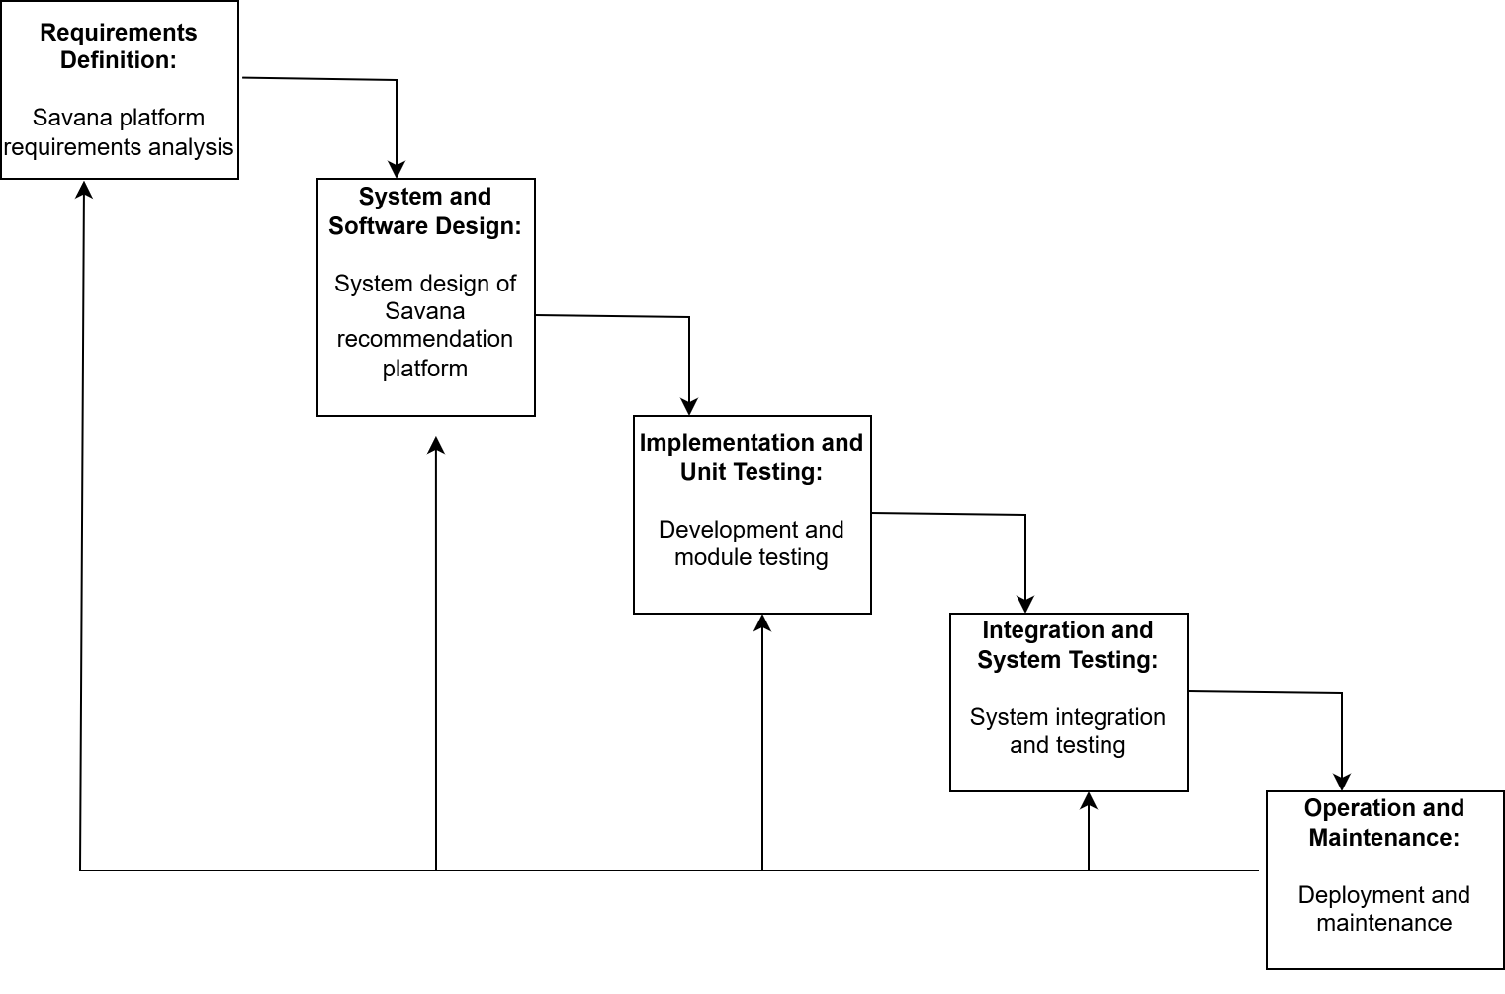
2. Incremental Model for Savana
The Incremental Model takes a different path, building the system in pieces. You handle requirements, design, build, and test—one chunk at a time. Roger S. Pressman and Ian Sommerville both say this lets you roll out working parts bit by bit.

For Savana, this fits pretty well. Instead of trying to launch the entire platform at once, the team can start with the basics—user sign-up, login, maybe browsing. Next, they can add features like product suggestions and purchases. Later, they can roll out more advanced stuff—AI-powered buying, secure payments, order tracking, dashboards, ratings, you name it.

Every time a new feature goes live, the team reviews how it’s working and plans what’s next. This is great because Savana has to keep up with trends and what users want. If they need to add a new deal or tweak something, they can do it without breaking what already works.

Users get early access to parts of the system, which is a win. The team can work on security, scalability, and user experience as they go. Plus, it’s easier on the budget—building in chunks means you’re not gambling everything at once. The Incremental Model just makes sense for Savana.
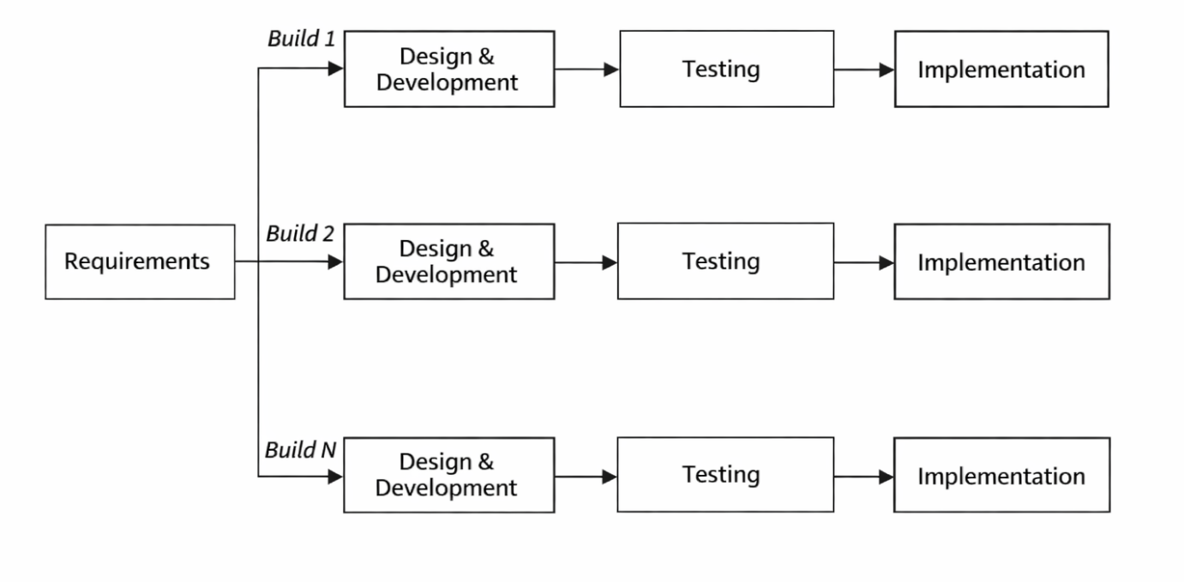

3. Spiral Model - Explanation for Savana
The Spiral Model breaks the work into cycles, tackling one round at a time. First up: safety. Before any coding, the team checks for risks like fraud—especially important with payments and logins. Once they’re sure things are secure, they set goals and get to work. After building, they test again and gather feedback from users before starting the next cycle.

Since Savana’s handling sensitive info, it can’t afford to get bogged down by last-minute changes or security slip-ups. The Spiral Model keeps things flexible but careful—always looping back to check for problems and keep the platform stable.
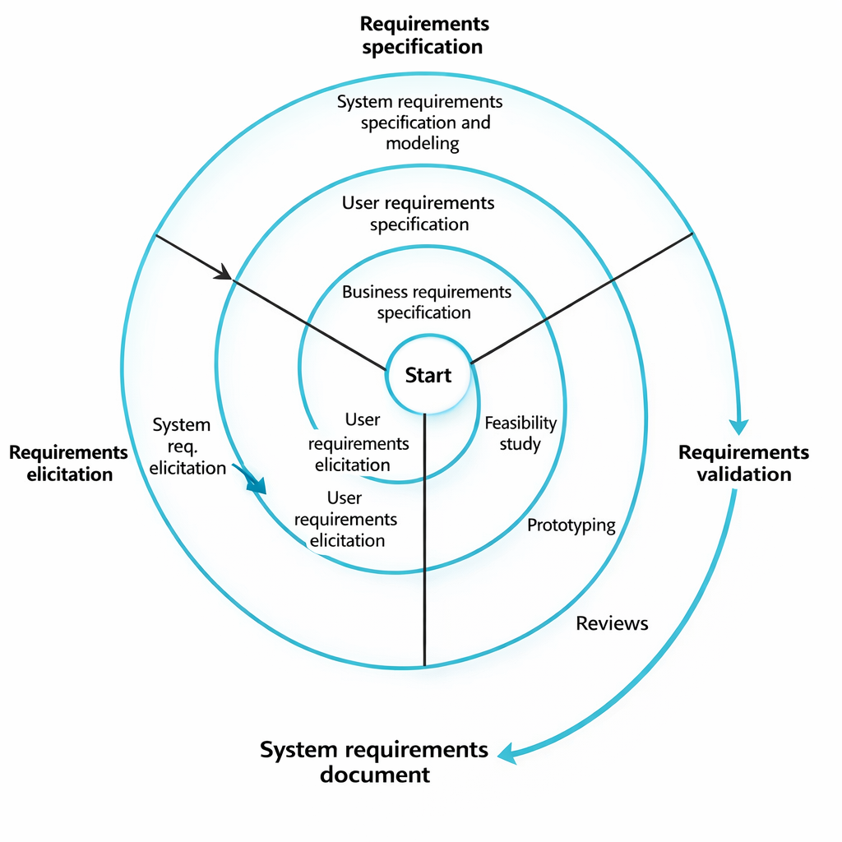

REQUIREMENT DOCUMENTS

Functional Requirements
- The system needs solid roles for everyone. Savana’s app should let users log in and easily see info like payment plans or addresses. Buyers need to search for products and get full details when they click on one.
- Shopping has to be smooth. Payments should be simple and quick, and tracking needs to be fast too.
- Admins should check users and sales without any hassle. Sellers need tools to manage their posts and add all the info needed to get set up.

Non-Functional Requirements
These cover how Savana actually runs. The platform needs to be reliable, fast, and easy to use. Data quality has to be high, and users expect quick responses. Security matters more as Savana grows, and simple, stable features help keep users coming back. Uploads should happen regularly, and downtime needs to be minimal—people won’t stick around if the platform’s always offline.
Requirements Validation Strategy

For SAVANA, the team sits down together and talks through what users need. They decide who’s responsible for what, sketch out basic mockups, and hash things out until everyone’s clear. This isn’t just about checking boxes—it’s about making sure users actually get what they want.

They break things up and look at each part, asking, “Is this secure? Will this hold up over time?” Keeping users happy matters, but security and future-proofing are right up there too. They use test cases to pin down roles and watch out for security gaps.

Challenges in Requirements Engineering
Defining who does what sounds simple, but as soon as you add a new feature, everything shifts. Costs get in the way, and sometimes you’re waiting on suppliers, so things get missed or have to change.

Speed is another issue. People want things fast, but security needs more time. Reviewing roles can drag on, especially if you’re trying to get it right. That’s a headache.

Results and Analysis
After talking things through, the team laid out the key roles for SAVANA. They started with a waterfall approach, but they’re not glued to it—if it stops working, they’ll switch things up. Small tests and tweaks happen along the way. The main thing? Safety and security. If the system needs to adapt, the approach will too.

Comparisons

Handling Functional Requirements
Waterfall works when everything’s planned out. The trouble starts when people want changes at the last minute—it’s a pain to squeeze those in. Spiral is better if you know changes are coming. It delivers what people ask for and makes more sense from the get-go.

Handling Non-Functional Requirements
Things like safety and being able to sell anywhere really matter. That’s why these requirements can’t be an afterthought.

Risk Management
If things go off track with waterfall, it’s hard to catch problems early. There’s not much risk reduction in testing. Spiral, though, checks for issues all along the way, which fits SAVANA’s needs better.

Change Management
Change is expensive in the middle of a project. It’s tough to get everyone on board. Spiral makes it easier to change things as you go, once the basics are in place.

Time Constraints
Waterfall takes a while because everything wraps up at the very end. You can see the progress, but it’s slow. Spiral adds tests you’d probably miss otherwise, but sometimes you have to redo old work, and that eats up time.

Cost Constraints
Waterfall looks cheap at first, but costs can balloon at the end if you miss something. With spiral, you review costs step by step, so you’re less likely to get hit with a giant bill at the finish line.

User Feedback
With waterfall, users mostly see the final product—there’s not much back-and-forth. Spiral brings users into the process, so their feedback actually shapes what gets built.

Applicability to SAVANA Application
Doing less often means doing it right, but it can slow things down. Spiral keeps changes safe and usable for everyone.

Limitations and Future Work
This strategy fits SAVANA’s needs on paper, but nobody’s run it with real buyers yet. So far, it’s just a plan.

Testing with actual users should happen soon. The team will focus on making the system work smoothly and might look into bringing in more tools or connecting with other systems.

Conclusion
This section lays out what’s been done and checks if the system suits SAVANA. It also touches on features like the swipe tool and smaller components. Roles guide how everything works, setting up a method that covers all the bases.

The main goal is to get the system running smoothly. The setup should be ready, but not overloaded. Everything needs to work together—steady, not rushed. The Swpro tool stands out for safety and long-term use.

Bottom line: For a market setup, focusing on the right parts and using Swpro helps make sure everything works as it should.

REFERENCES
- Pressman, R. S. (2014). Software Engineering: A Practitioner’s Approach.
- Sommerville, I. (2016). Software Engineering (10th Edition).
- Boehm, B. (1988). Spiral Model of Software Development.
- ISO/IEC/IEEE 29148:2018 – Requirements Engineering.
- Schwaber, K., & Sutherland, J. (2020). Scrum Guide.
- AWS Architecture Documentation.

DECLARATION OF ACADEMIC INTEGRITY
I hereby declare that this report is my original work. All references used have been properly cited. No part of this work has been copied without acknowledgement.

Date: 15-02-2026

